# **Manual calculation of classification report values for SVM model**

Below is the confusion matrix derived through classification Algorithm using SVM.

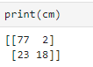

Below is the classification report derived through classification Algorithm using SVM.

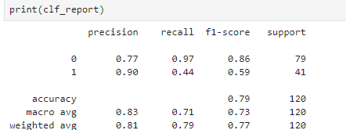

## **Accuracy**

### **Formula:**



For the above case:

Accuracy = (77+18)/ (77+18+23+2) = 95/120 = 0.7916

## **Precision**

## **Formula:**



For the above case Precision value for unpurchased:

Precision = 77/ (77+23) =77/100 = 0.77

For the above case Precision value for unpurchased:

Precision = 18/ (18+2) =18/20 = 0.90

## **Recall**

### **Formula:**



For the above case Recall value for non-purchased:

Recall=77/ (77+2) =77/79 = 0.974

For the above case Recall value for purchased:

Recall=18/ (18+23) =18/41 = 0.439

# **F1 Score**

### **Formula:**



For the above case for unpurchased:

F1-Score: = (2* 0.77* 0.97)/ (0.77+ 0.97) = 0.8585

For the above case for unpurchased:

F1-Score: = (2* 0.90* 0.44)/ (0.90+ 0.44) = 0.5910

## **Macro-Average**

### **Formula:**

Macro-Average of Precision = Precision (Unpurchased)+precision(purchased)/2

For the above case macro-average of precision:

Macro-Average= (0.77+0.90)/2=0.835

For the above case macro-average of Recall:

Macro-Average of Recall = Recall (Unpurchased)+Recall(purchased)/2

Macro-Average= (0.97+0.439)/2= 0.7045

## **Weighted-Average**

#### **Formula:**

Weighted-Average of Precision = Precision (Unpurchased) x (Total Unpurchased/Total dataset)

+precision (purchased) x (Total purchased/Total dataset)

For the above case Weighted-average of precision:

Weighted-Average= ((0.77) *(80/120) + (0.90) * (41/120)) = (0.513+0.3075) = 0.820

Weighted-Average of Recall = Recall (Unpurchased) x (Total Unpurchased/Total dataset)

+ Recall (purchased) x (Total purchased/Total dataset)

For the above case Weighted-average of recall:

Weighted-Average= ((0.97) *(80/120) + (0.439) * (41/120)) = 0.646+0.1499 = 0.795